8. **Working with Multiple Tables in SQL**

**1. Write a query to display the last name, department number, and name for all employees.**

**Ans: select e.lastname, e.department_id**

**from employees e**

**join department_1 d on d.departmentid = e.department_id;**

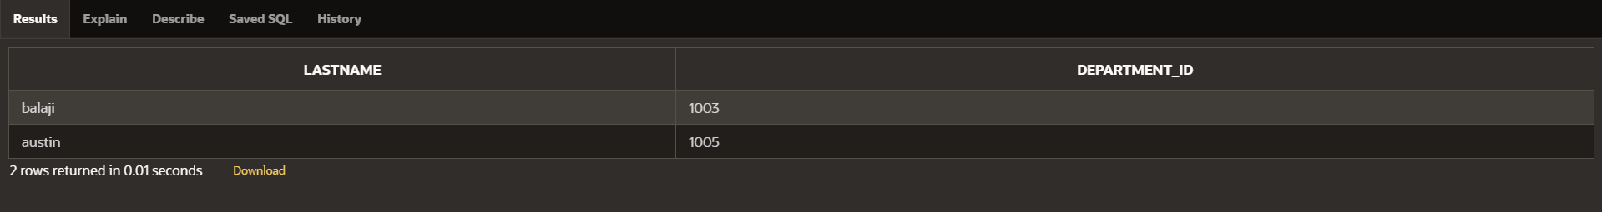

**2. Create a unique listing of all jobs that are in department 80. Include the location of the department in the output.**

**Ans: select e.job , d.country_loc**

**from employees e**

**join department_1 d on e.job = d.jobp;**



**3. Write a query to display the employee last name, department name, location ID, and city of all employees who earn a commission.**

**Ans: select e.lastname, e.department_id,d.country,d.country_loc**

**from employees e**

**join department_1 d on e.department_id = d.departmentid**

**where e.commission_pct is not null;**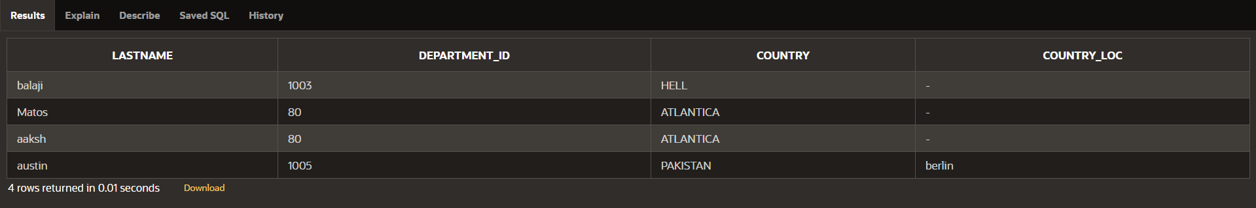

4. Display the employee last name and department name for all employees who have an a(lowercase) in their last names. P

Ans: SELECT e.lastname, d.jobp

FROM employees e

JOIN department_1 d ON e.department_id = d.departmentid

WHERE LOWER(e.lastname) LIKE '%a%';

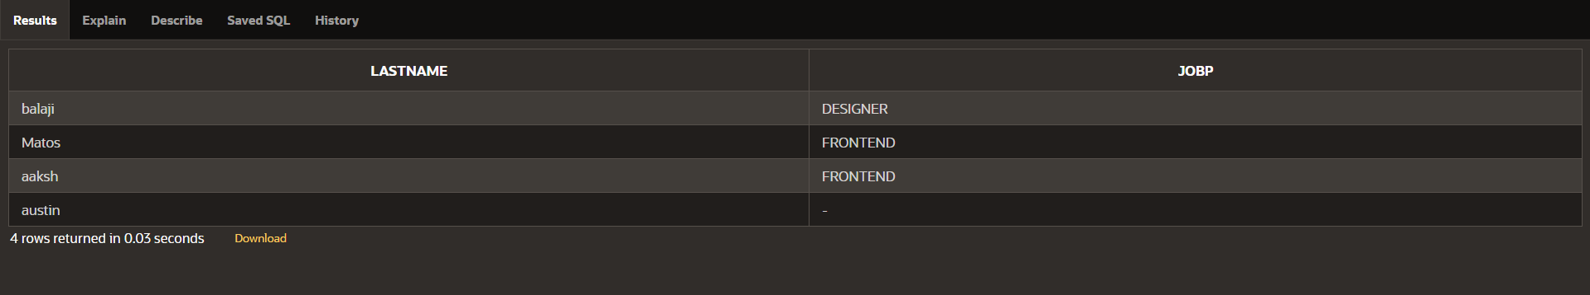

5. Write a query to display the last name, job, department number, and department name for all employees who work in Toronto.

Ans: select e.lastname, e.job, e.department_id,d.jobp

from employees e

join department_1 d on e.department_id = d.DEPARTMENTID

where d.country_loc='toronto'

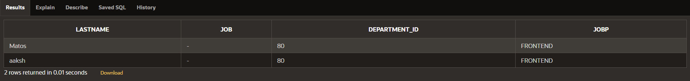

6. Display the employee last name and employee number along with their manager‘s last name and manager number. Label the columns Employee, Emp#, Manager, and Mgr#, Respectively

Ans: select e.lastname as employee, e.employee_id as emp#,

m.lastname as manager, m.manager_id as mgr#

from employees e

left join manager m on e.manager_id = m.manager_id;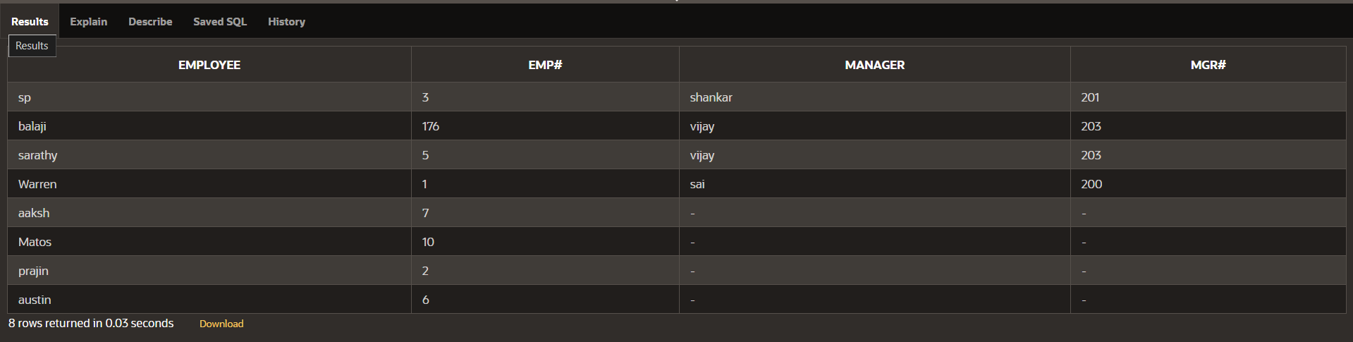

7. Modify lab4_6.sql to display all employees including King, who has no manager. Order the results by the employee number.

Ans: select lastname from employees where manager_id is null

order by employee_id;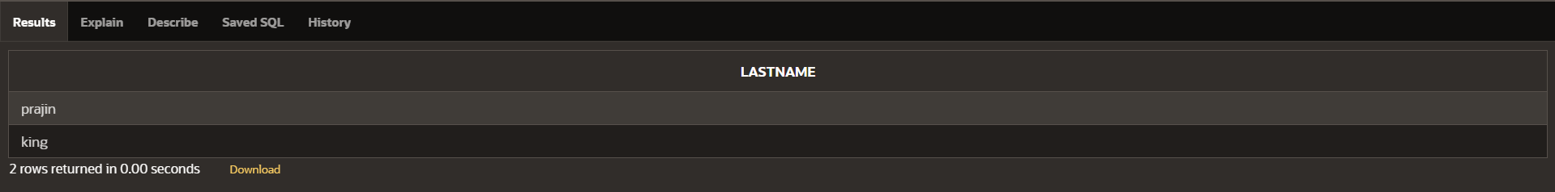

8. Create a query that displays employee last names, department numbers, and all the employees who work in the same department as a given employee. Give each column an appropriate label.

Ans: SELECT e1.lastname AS Employee, e1.department_id,

e2.lastname AS Colleague

FROM employees e1

JOIN employees e2 ON e1.department_id = e2.department_id

WHERE e1.employee_id != e2.employee_id

ORDER BY e1.department_id;

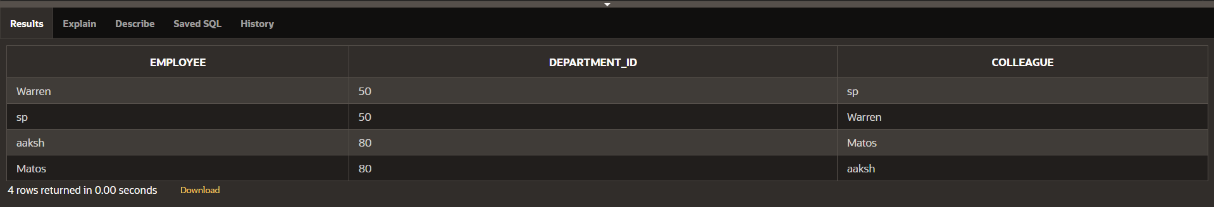

9. Show the structure of the JOB_GRADES table. Create a query that displays the name, job, department name, salary, and grade for all employees

Ans: select e.lastname, e.job, d.jobc,e.salary,d.grade

from employees e

join department_1 d on e.department_id = d.departmentid

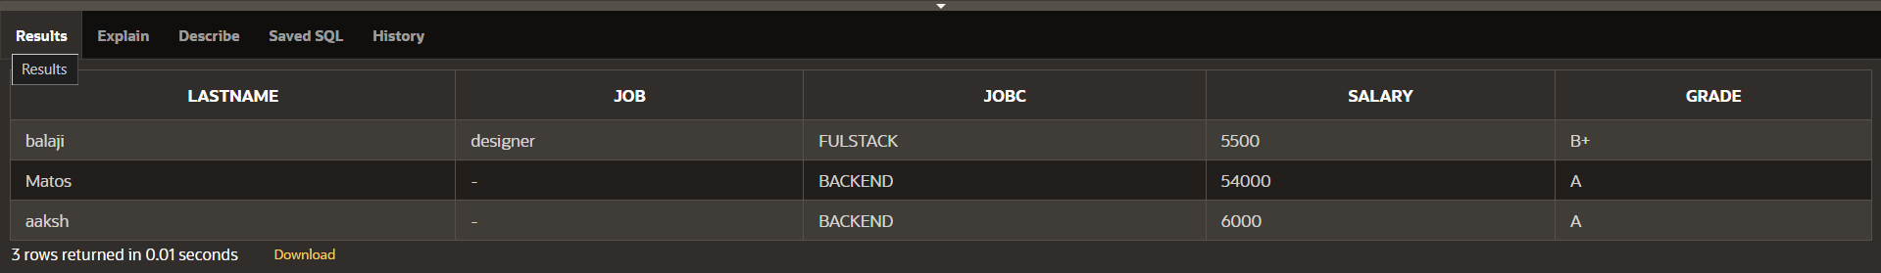

10. Create a query to display the name and hire date of any employee hired after employee Davies.

Ans: SELECT e.lastname, e.hiredate

FROM employees e

WHERE e.hiredate > (SELECT hiredate FROM employees WHERE lastname = 'davies');

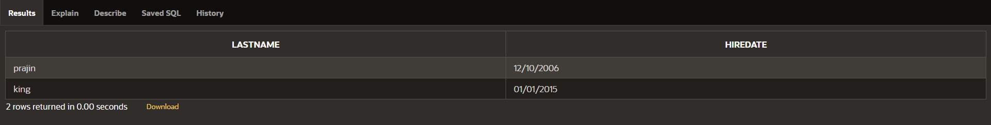

11. Display the names and hire dates for all employees who were hired before their managers, along with their manager‘s names and hire dates. Label the columns Employee, Emp Hired, Manager, and Mgr Hired, respectively.

Ans: SELECT e.lastname AS Employee, e.hiredate AS "Emp Hired",

m.lastname AS Manager, m.hiredate AS "Mgr Hired"

FROM employees e

JOIN employees m ON e.manager_id = m.manager_id

WHERE e.hiredate < m.hiredate

ORDER BY e.hiredate;